Lab - Configure a Site-to-Site VPN ( THY DAYUTH )

Topology
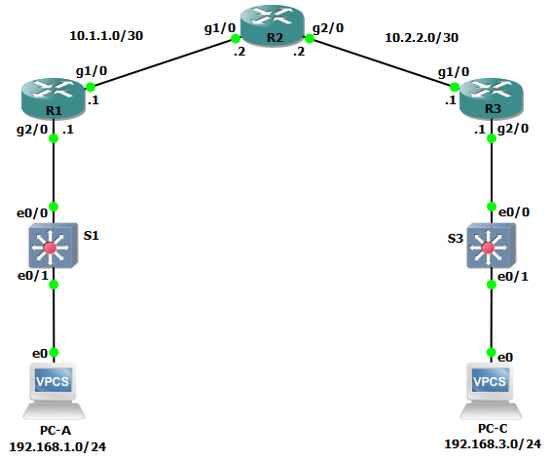

Addressing Table
Device | Interface | IP Address | Subnet Mask | Default Gateway | Switch Port
R1 | G0/0/1 | 192.168.1.1 | 255.255.255.0 | N/A | S1 F0/5
R1 | G0/0/0 | 10.1.1.1 | 255.255.255.252 | N/A | N/A
R2 | G0/0/0 | 10.1.1.2 | 255.255.255.252 | N/A | N/A
R2 | G0/0/1 | 10.2.2.2 | 255.255.255.252 | N/A | N/A
R3 | G0/0/1 | 192.168.3.1 | 255.255.255.0 | N/A | S3 F0/5
R3 | G0/0/0 | 10.2.2.1 | 255.255.255.252 | N/A | N/A
PC-A | NIC | 192.168.1.3 | 255.255.255.0 | 192.168.1.1 | S1 F0/6
PC-C | NIC | 192.168.3.3 | 255.255.255.0 | 192.168.3.1 | S3 F0/18
Blank Line, No additional information

Objectives
Part 1: Configure Basic Device Settings
- Configure hostnames, interface IP addresses, and access passwords.
- Configure the OSPF dynamic routing protocol.
Part 2: Configure a Site-to-Site VPN Using Cisco IOS
- Configure IPsec VPN settings on R1 and R3.
- Verify site-to-site IPsec VPN configuration.
- Test IPsec VPN operation.

Background / Scenario
VPNs can provide a secure method of transmitting data over a public network, such as the Internet. VPN connections can help reduce the costs associated with leased lines. Site-to-Site VPNs typically provide a secure (IPsec or other) tunnel between a branch office and a central office. Another common implementation of VPN technology is remote access to a corporate office from a telecommuter location, such as a small office or home office.
In this lab, you will build and configure a multi-router network, use Cisco IOS to configure a site-to-site IPsec VPN, and then test the VPN. The IPsec VPN tunnel is from R1 to R3 via R2. R2 acts as a pass-through and has no knowledge of the VPN. IPsec provides secure transmission of sensitive information over unprotected networks, such as the Internet. IPsec acts at the network layer and protecting and authenticating IP packets between participating IPsec devices (peers), such as Cisco routers.
Note: The routers used with hands-on labs are Cisco 4221 with Cisco IOS XE Release 16.9.6 (universalk9 image). The switches used in the labs are Cisco Catalyst 2960+ with Cisco IOS Release 15.2(7) (lanbasek9 image). Other routers, switches, and Cisco IOS versions can be used. Depending on the model and Cisco IOS version, the commands available and the output produced might vary from what is shown in the labs. Refer to the Router Interface Summary Table at the end of the lab for the correct interface identifiers.
Note: Before you begin, ensure that the routers and the switches have been erased and have no startup configurations.

Required Resources
- 3 Routers (Cisco 4221 with Cisco XE Release 16.9.6 universal image or comparable with a Security Technology Package license)
- 2 Switches (Cisco 2960+ with Cisco IOS Release 15.2(7) lanbasek9 image or comparable)
- 2 PCs (Windows OS with a terminal emulation program, such as PuTTY or Tera Term installed)
- Console cables to configure Cisco networking devices
- Ethernet cables as shown in the topology

Configure Basic Device Settings
In Part 1, you will set up the network topology and configure basic settings, such as the interface IP addresses, dynamic routing, device access, and passwords.
Note: All tasks should be performed on R1, R2, and R3. The procedure for R1 is shown here as an example.

Cable the network as shown in the topology.
Attach the devices as shown in the topology diagram and cable as necessary.

Configure basic settings for each router.
      - Configure hostnames, as shown in the topology.
      - Configure the interface IP addresses, as shown in the Addressing Table.

Disable DNS lookup.
Disable DNS lookup to prevent the router from attempting to translate incorrectly entered commands.
R1(config)# no ip domain lookup

Configure the OSPF routing protocol on R1, R2, and R3.
      - On R1, use the following commands:
R1(config)# router ospf 101
R1(config-router)# network 192.168.1.0 0.0.0.255 area 0
R1(config-router)# network 10.1.1.0 0.0.0.3 area 0
      - On R2, use the following commands:
R2(config)# router ospf 101
R2(config-router)# network 10.1.1.0 0.0.0.3 area 0
R2(config-router)# network 10.2.2.0 0.0.0.3 area 0
      - On R3, use the following commands:
R3(config)# router ospf 101
R3(config-router)# network 192.168.3.0 0.0.0.255 area 0
R3(config-router)# network 10.2.2.0 0.0.0.3 area 0

Configure PC host IP settings.
      - Configure a static IP address, subnet mask, and default gateway for PC-A, as shown in the IP Addressing Table.
      - Configure a static IP address, subnet mask, and default gateway for PC-C, as shown in the IP Addressing Table.

Verify basic network connectivity.
      - Ping from R1 to the R3 G0/0/1 interface at IP address 192.168.3.1.
If the pings are unsuccessful, troubleshoot the basic device configurations before continuing.
      - Ping from PC-A on the R1 LAN to PC-C on the R3 LAN.
If the pings are unsuccessful, troubleshoot the basic device configurations before continuing.
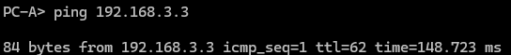
Note: If you can ping from PC-A to PC-C, you have demonstrated that the OSPF routing protocol is configured and functioning correctly. If you cannot ping, but the device interfaces are up and IP addresses are correct, use the show run and show ip route commands to help identify routing protocol-related problems.

Configure and encrypt passwords.
Note: Passwords in this task are set to a minimum of 10 characters but are relatively simple for the benefit of performing the lab. More complex passwords are recommended in a production network.
Configure the same settings for R1 and R3.
      - Configure a minimum password length.
Use the security passwords command to set a minimum password length of 10 characters.
      - Configure the enable secret password on both routers with a password of cisco12345. Use the type 9 (SCRYPT) hashing algorithm.
      - Create a local admin01 account using admin01pass for the password. Use the type 9 (SCRYPT) hashing algorithm.

Configure the console line.
Configure the console to use the local database for login. For additional security, configure the line to log out after five minutes of inactivity. Issue the logging synchronous command to prevent console messages from interrupting command entry.

Configure SSH Server.
      - Configure a domain name netsec.com.
      - Configure the RSA keys with 2048 for the number of modulus bits.
      - Issue the command to force the use of SSH version 2.
      - Configure the vty lines on R1 and R3 to use the local database for login. Remote access to the routers should only be allowed using SSH. Configure the vty lines to logout after five minutes of inactivity.

Save the basic running configuration for all three routers.
Save the running configuration to the startup configuration from the privileged EXEC mode prompt on R1, R2, and R3.
R1# copy running-config startup-config

Configure a Site-to-Site VPN with Cisco IOS
In Part 2 of this lab, you will configure an IPsec VPN tunnel between R1 and R3 that passes through R2. You will configure R1 and R3 using the Cisco IOS CLI. You will then review and test the resulting configuration.
Note: Because no tunnel is yet in place, PC-A should still be able to ping PC-C. If not, troubleshoot the basic device configurations before continuing.
  - Configure IPsec VPN Settings on R1 and R3.

Enable IKE policies on R1 and R3.
IPsec is an open framework that allows for the exchange of security protocols as new technologies, and encryption algorithms as they are developed.
There are two central configuration elements in the implementation of an IPsec VPN:
- Implement Internet Key Exchange (IKE) parameters
- Implement IPsec parameters
      - Verify that IKE is supported and enabled.
IKE Phase 1 defines the key exchange method used to pass and validate IKE policies between peers. In IKE Phase 2, the peers exchange and match IPsec policies for the authentication and encryption of data traffic.
IKE must be enabled for IPsec to function. IKE is enabled, by default, on IOS images with cryptographic feature sets. If it is disabled, you can enable it with the crypto isakmp enable command. Use this command to verify that the router IOS supports IKE and that it is enabled.
R1(config)# crypto isakmp enable

R3(config)# crypto isakmp enable
Note: If you cannot execute this command on the router, you must upgrade to the IOS image that includes the Cisco cryptographic services.
      - Establish an ISAKMP policy and view the available options.
To allow IKE Phase 1 negotiation, you must create an ISAKMP policy and configure a peer association for that ISAKMP policy. An ISAKMP policy defines the authentication and encryption algorithms and the hash function used to send control traffic between the two VPN endpoints. When an ISAKMP security association has been accepted by the IKE peers, IKE Phase 1 has been completed. IKE Phase 2 parameters will be configured later.
Issue the crypto isakmp policy number global configuration mode command on R1 for policy 10.
R1(config)# crypto isakmp policy 10
      - View the various IKE parameters available using Cisco IOS help by typing a question mark (?).
R1(config-isakmp)# ?
ISAKMP commands:
authentication Set authentication method for protection suite
default Set a command to its defaults
encryption Set encryption algorithm for protection suite
exit Exit from ISAKMP protection suite configuration mode
group Set the Diffie-Hellman group
hash Set hash algorithm for protection suite
lifetime Set lifetime for ISAKMP security association
no Negate a command or set its defaults

Configure the IKE Phase 1 ISAKMP policy on R1 and R3.
Your choice of an encryption algorithm determines how confidential the control channel between the endpoints is. The hash algorithm controls data integrity, ensuring that the data received from a peer has not been tampered with in transit. The authentication type ensures that the packet was sent and signed by the remote peer. The Diffie-Hellman group is used to create a secret key shared by the peers that has not been sent across the network.
      - Configure an ISAKMP policy with a priority of 10. Use pre-shared key as the authentication type, aes 256 for the encryption algorithm, sha as the hash algorithm, and the Diffie-Hellman group 24 key exchange. Give the policy a lifetime of 3600 seconds (one hour).
Note: Older versions of Cisco IOS do not support AES 256 encryption and SHA as a hash algorithm. Substitute whatever encryption and hashing algorithm your router supports. Ensure that the same changes are made on R3 in order to be in sync.
R1(config)# crypto isakmp policy 10
R1(config-isakmp)# hash sha
R1(config-isakmp)# authentication pre-share
R1(config-isakmp)# group 24
R1(config-isakmp)# lifetime 3600
R1(config-isakmp)# encryption aes 256
R1(config-isakmp)# end
      - Configure the same policy on R3.
R3(config)# crypto isakmp policy 10
R3(config-isakmp)# hash sha
R3(config-isakmp)# authentication pre-share
R3(config-isakmp)# group 24
R3(config-isakmp)# lifetime 3600
R3(config-isakmp)# encryption aes 256
R3(config-isakmp)# end
      - Verify the IKE policy with the show crypto isakmp policy command.
R1# show crypto isakmp policy

Global IKE policy
Protection suite of priority 10
encryption algorithm: AES - Advanced Encryption Standard (256 bit keys).
hash algorithm: Secure Hash Standard
authentication method: Pre-Shared Key
Diffie-Hellman group: #24 (2048 bit, 256 bit subgroup)
lifetime: 3600 seconds, no volume limit
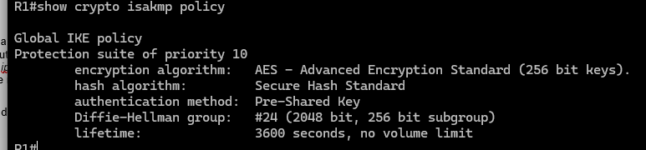

Configure pre-shared keys.
Because pre-shared keys are used as the authentication method in the IKE policy, a key must be configured on each router that points to the other VPN endpoint. These keys must match for authentication to be successful. The global configuration mode crypto isakmp key key-string address ip-address command is used to enter a pre-shared key. Use the IP address of the remote peer, which is the remote interface that the peer would use to route traffic to the local router.
Which IP addresses should you use to configure the IKE peers, given the topology diagram and IP addressing table?
R1 G0/0/0 (10.1.1.1) and R3 G0/0/0 (10.2.2.1) are the designated endpoints for standard traffic between these routers.
      - Each IP address that is used to configure the IKE peers is also referred to as the IP address of the remote VPN endpoint. Configure the pre-shared key of cisco123 on router R1. Production networks should use a complex key. This command points to the remote peer R3 G0/0/0 IP address.
R1(config)# crypto isakmp key cisco123 address 10.2.2.1
      - Configure the pre-shared key cisco123 on router R3. The command for R3 points to the R1 S0/0/0 IP address.
R3(config)# crypto isakmp key cisco123 address 10.1.1.1

Configure the IPsec transform set and lifetime.
      - The IPsec transform set is another crypto configuration parameter that routers negotiate to form a security association. To create an IPsec transform set, use the crypto ipsec transform-set tag command where tag is a name configured by the administrator. Use ? to see which parameters are available.
R1(config)# crypto ipsec transform-set R1-R3 ?
ah-md5-hmac AH-HMAC-MD5 transform
ah-sha-hmac AH-HMAC-SHA transform
ah-sha256-hmac AH-HMAC-SHA256 transform
ah-sha384-hmac AH-HMAC-SHA384 transform
ah-sha512-hmac AH-HMAC-SHA512 transform
esp-192-aes ESP transform using AES cipher (192 bits)
esp-256-aes ESP transform using AES cipher (256 bits)
esp-3des ESP transform using 3DES(EDE) cipher (168 bits)
esp-aes ESP transform using AES cipher
esp-des ESP transform using DES cipher (56 bits)
esp-gcm ESP transform using GCM cipher
esp-gmac ESP transform using GMAC cipher
esp-md5-hmac ESP transform using HMAC-MD5 auth
esp-null ESP transform w/o cipher
esp-seal ESP transform using SEAL cipher (160 bits)
esp-sha-hmac ESP transform using HMAC-SHA auth
esp-sha256-hmac ESP transform using HMAC-SHA256 auth
esp-sha384-hmac ESP transform using HMAC-SHA384 auth
esp-sha512-hmac ESP transform using HMAC-SHA512 auth
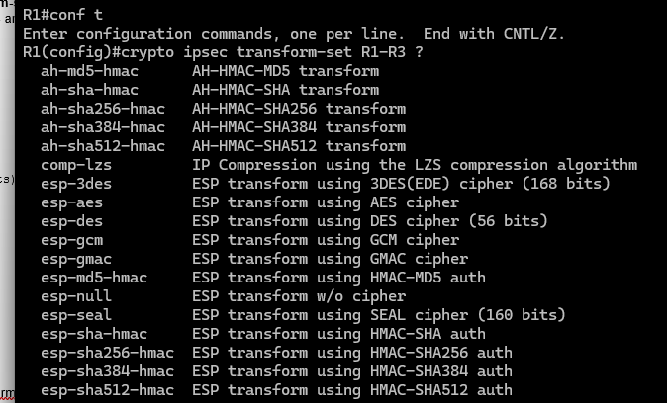
      - On R1 and R3, create a transform set with tag R1-R3 and use an ESP transform with an AES 256 cipher with ESP and the SHA hash function. The transform sets must match on both ends of the VPN.
R1(config)# crypto ipsec transform-set 50 esp-aes 256 esp-sha-hmac
R1(cfg-crypto-trans)# exit

R3(config)# crypto ipsec transform-set 50 esp-aes 256 esp-sha-hmac
R3(cfg-crypto-trans)# exit
What is the function of the IPsec transform set?
The IPsec transform set defines the specific combinations of encryption, authentication, and integrity algorithms applied to data packets transitioning through the tunnel.
      - You can also change the IPsec security association lifetime from the default of 3600 seconds. On R1 and R3, set the IPsec security association lifetime to 30 minutes, or 1800 seconds.
R1(config)# crypto ipsec security-association lifetime seconds 1800

R3(config)# crypto ipsec security-association lifetime seconds 1800

Define interesting traffic.
To make use of the IPsec encryption with the VPN, it is necessary to define extended access lists to tell the router which traffic to encrypt. A packet that is permitted by an access list used for defining IPsec traffic is encrypted if the IPsec session is configured correctly. A packet that is denied by the IPsec access list is not dropped. It is sent unencrypted. Also, like any other access list, there is an implicit deny at the end, which means the default action is to not encrypt traffic. If there is no IPsec security association correctly configured, no traffic is encrypted and traffic is forwarded unencrypted.
In this scenario, from the perspective of R1, the traffic you want to encrypt is traffic going from R1’s Ethernet LAN to R3’s Ethernet LAN or vice versa from the perspective of R3. These access lists are used outbound on the VPN endpoint interfaces and must mirror each other.
      - Configure the IPsec VPN interesting traffic ACL on R1.
R1(config)# access-list 101 permit ip 192.168.1.0 0.0.0.255 192.168.3.0 0.0.0.255
      - Configure the IPsec VPN interesting traffic ACL on R3.
R3(config)# access-list 101 permit ip 192.168.3.0 0.0.0.255 192.168.1.0 0.0.0.255

Question:
Does IPsec evaluate whether the access lists are mirrored as a requirement to negotiate its security association?
Yes, IPsec requires perfectly mirrored access lists to establish a Security Association (SA). If the 'interesting traffic' definitions on both peers do not match symmetrically, the tunnel will fail to form

Create and apply a crypto map.
A crypto map associates traffic that matches an access list to a peer and various IKE and IPsec settings. After the crypto map is created, it can be applied to one or more interfaces. The interfaces that it is applied to should be the ones facing the IPsec peer.
To create a crypto map, use crypto map <name> <sequence-num> <type> command in global configuration mode to enter crypto map configuration mode for that sequence number. Multiple crypto map statements can belong to the same crypto map and are evaluated in ascending numerical order. Enter crypto map configuration mode on R1. Use a type of ipsec-isakmp, which means IKE is used to establish IPsec security associations.
      - Create the crypto map on R1, name it CMAP, and use 10 as the sequence number. A message displays after the command is issued.
R1(config)# crypto map CMAP 10 ipsec-isakmp
% NOTE: This new crypto map will remain disabled until a peer
and a valid access list have been configured.
      - Use the match address <access-list> command to specify which access list defines which traffic to encrypt.
R1(config-crypto-map)# match address 101
      - To view the list of possible set commands that you can do with a crypto map, use the help function.
R1(config-crypto-map)# set ?
identity Identity restriction.
ip Interface Internet Protocol config commands
isakmp-profile Specify isakmp Profile
nat Set NAT translation
peer Allowed Encryption/Decryption peer.
pfs Specify pfs settings
reverse-route Reverse Route Injection.
security-association Security association parameters
transform-set Specify list of transform sets in priority order
      - Setting a peer IP or hostname is required. Set it to R3’s remote VPN endpoint interface using the following command.
R1(config-crypto-map)# set peer 10.2.2.1
      - Use the set transform-set tag command to hard code the transform set to be used with this peer. Set the perfect forwarding secrecy type using the set pfs type command, and modify the default IPsec security association life time with the set security-association lifetime seconds seconds command.
R1(config-crypto-map)# set pfs group24
R1(config-crypto-map)# set transform-set R1-R3
R1(config-crypto-map)# set security-association lifetime seconds 900
R1(config-crypto-map)# exit
      - Create a mirrored matching crypto map on R3.
R3(config)# crypto map CMAP 10 ipsec-isakmp
R3(config-crypto-map)# match address 101
R3(config-crypto-map)# set peer 10.1.1.1
R3(config-crypto-map)# set pfs group24
R3(config-crypto-map)# set transform-set R1-R3
R3(config-crypto-map)# set security-association lifetime seconds 900
R3(config-crypto-map)# exit
      - Apply the crypto maps to the appropriate interfaces on R1 and R3.
Note: . The router generates a notification that crypto is now on. However, the SAs are not established until the crypto map has been activated by interesting traffic
R1(config)# interface G0/0/0
R1(config-if)# crypto map CMAP
*Jan 28 04:09:09.150: %CRYPTO-6-ISAKMP_ON_OFF: ISAKMP is ON
R1(config)# end

R3(config)# interface G0/0/1
R3(config-if)# crypto map CMAP
*Jan 28 04:10:54.138: %CRYPTO-6-ISAKMP_ON_OFF: ISAKMP is ON
R3(config)# end
  - Verify the Site-to-Site IPsec VPN Configuration.

Verify the IPsec configuration on R1 and R3.
      - Previously, you used the show crypto isakmp policy command to display the configured ISAKMP policies on the router. The show crypto ipsec transform-set command displays the configured IPsec policies in the form of the transform sets.
R1# show crypto ipsec transform-set
Transform set AES_GCM_256: { esp-gcm 256 }
will negotiate = { Transport, },

Transform set AES_CBC_256_HMAC_SHA1: { esp-256-aes esp-sha-hmac }
will negotiate = { Transport, },

Transform set AES_CBC_128_HMAC_SHA1: { esp-aes esp-sha-hmac }
will negotiate = { Transport, },

Transform set default: { esp-aes esp-sha-hmac }
will negotiate = { Transport, },

Transform set R1-R3: { esp-256-aes esp-sha-hmac }
will negotiate = { Tunnel, },
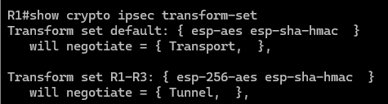

R3# show crypto ipsec transform-set
Transform set AES_GCM_256: { esp-gcm 256 }
will negotiate = { Transport, },

Transform set AES_CBC_256_HMAC_SHA1: { esp-256-aes esp-sha-hmac }
will negotiate = { Transport, },

Transform set AES_CBC_128_HMAC_SHA1: { esp-aes esp-sha-hmac }
will negotiate = { Transport, },

Transform set default: { esp-aes esp-sha-hmac }
will negotiate = { Transport, },

Transform set R1-R3: { esp-256-aes esp-sha-hmac }
will negotiate = { Tunnel, },
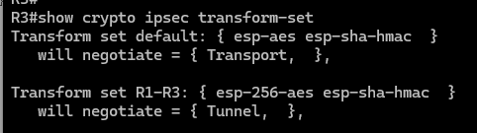
      - Use the show crypto map command to display the crypto maps that will be applied to the router.
R1# show crypto map
Crypto Map IPv4 "CMAP" 10 ipsec-isakmp
Peer = 10.2.2.1
Extended IP access list 101
access-list 101 permit ip 192.168.1.0 0.0.0.255 192.168.3.0 0.0.0.255
Current peer: 10.2.2.1
Security association lifetime: 4608000 kilobytes/900 seconds
Responder-Only (Y/N): N
PFS (Y/N): Y
DH group: group24
Mixed-mode : Disabled
Transform sets={
R1-R3: { esp-256-aes esp-sha-hmac } ,
}
Interfaces using crypto map CMAP:
GigabitEthernet0/0/0
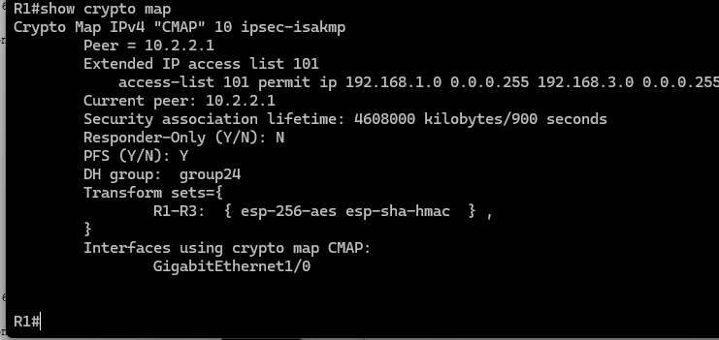
R3# show crypto map
Crypto Map IPv4 "CMAP" 10 ipsec-isakmp
Peer = 10.1.1.1
Extended IP access list 101
access-list 101 permit ip 192.168.3.0 0.0.0.255 192.168.1.0 0.0.0.255
Current peer: 10.1.1.1
Security association lifetime: 4608000 kilobytes/900 seconds
Responder-Only (Y/N): N
PFS (Y/N): Y
DH group: group24
Mixed-mode : Disabled
Transform sets={
R1-R3: { esp-256-aes esp-sha-hmac } ,
}
Interfaces using crypto map CMAP:
GigabitEthernet0/0/0
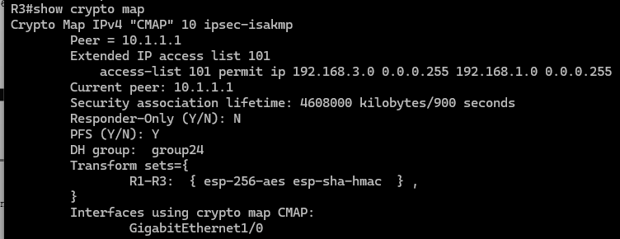
Note: The output of these show commands does not change if interesting traffic goes across the connection. You test various types of traffic in the next task.
  - Verify the IPsec VPN Operation.

Display ISAKMP security associations.
The show crypto isakmp sa command reveals that no IKE SAs exist yet. When interesting traffic is sent, this command output will change.
R1# show crypto isakmp sa
IPv4 Crypto ISAKMP SA
dst src state conn-id status

IPv6 Crypto ISAKMP SA
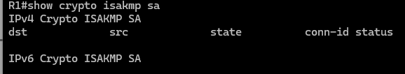

Display IPsec security associations.
The show crypto ipsec sa command shows the unused SA between R1 and R3.
Note: The number of packets sent across is zero, and there is a lack of any security associations listed toward the bottom of the output. The output for R1 is shown here.
R1# show crypto ipsec sa

interface: GigabitEthernet0/0/0
Crypto map tag: CMAP, local addr 10.1.1.1

protected vrf: (none)
local ident (addr/mask/prot/port): (192.168.1.0/255.255.255.0/0/0)
remote ident (addr/mask/prot/port): (192.168.3.0/255.255.255.0/0/0)
current_peer 10.2.2.1 port 500
PERMIT, flags={origin_is_acl,}
#pkts encaps: 0, #pkts encrypt: 0, #pkts digest: 0
#pkts decaps: 0, #pkts decrypt: 0, #pkts verify: 0
#pkts compressed: 0, #pkts decompressed: 0
#pkts not compressed: 0, #pkts compr. failed: 0
#pkts not decompressed: 0, #pkts decompress failed: 0
#send errors 0, #recv errors 0

local crypto endpt.: 10.1.1.1, remote crypto endpt.: 10.2.2.1
plaintext mtu 1500, path mtu 1500, ip mtu 1500, ip mtu idb GigabitEthernet0/0/0
current outbound spi: 0x0(0)
PFS (Y/N): N, DH group: none

inbound esp sas:

inbound ah sas:

inbound pcp sas:

outbound esp sas:

outbound ah sas:

outbound pcp sas:
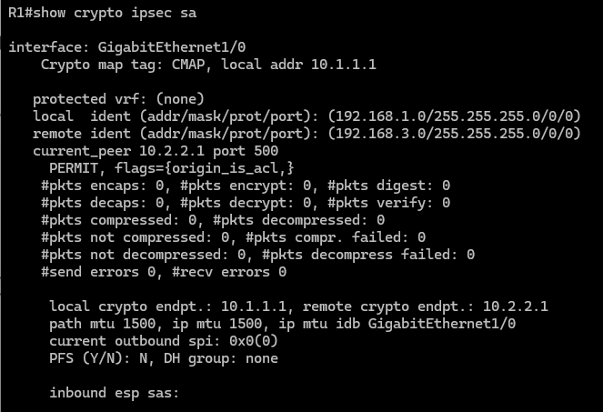

Question:
Why haven’t any SAs been negotiated?
The IPsec Security Association (SA) remains uninitiated because the defined 'interesting traffic' has not yet been detected. Without a matching packet to trigger the ACL, the negotiation process stays idle.

Generate some uninteresting test traffic and observe the results.
      - Ping from R1 to the R3 G0/0/0 interface IP address 10.2.2.1. These pings should be successful.
      - Issue the show crypto isakmp sa command.
      - Ping from R1 to the R3 G0/0/1 interface IP address 192.168.3.1. These pings should be successful.
      - Issue the show crypto isakmp sa command again.

Question:
Was an SA created for these pings? Explain.
Type your answers here.
      - Issue the debug ip ospf hello command. You should see OSPF hello packets passing between R1 and R3.
R1# debug ip ospf hello
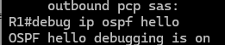
OSPF hello events debugging is on
R1#
*Apr 7 18:04:46.467: OSPF: Send hello to 224.0.0.5 area 0 on GigabitEthernet0/1 from 192.168.1.1
*Apr 7 18:04:50.055: OSPF: Send hello to 224.0.0.5 area 0 on Serial0/0/0 from 10.1.1.1
*Apr 7 18:04:52.463: OSPF: Rcv hello from 10.2.2.2 area 0 from Serial0/0/0 10.1.1.2
*Apr 7 18:04:52.463: OSPF: End of hello processing
*Apr 7 18:04:55.675: OSPF: Send hello to 224.0.0.5 area 0 on GigabitEthernet0/1 from 192.168.1.1
*Apr 7 18:04:59.387: OSPF: Send hello to 224.0.0.5 area 0 on Serial0/0/0 from 10.1.1.1
*Apr 7 18:05:02.431: OSPF: Rcv hello from 10.2.2.2 area 0 from Serial0/0/0 10.1.1.2
*Apr 7 18:05:02.431: OSPF: End of hello processing
      - Turn off debugging with the no debug ip ospf hello or undebug all command.
      - Re-issue the show crypto isakmp sa command.

Question:
Was an SA created between R1 and R3? Explain.
IPsec remained idle as the test pings used the R1 interface address (10.1.1.1) instead of the protected 192.168.1.0/24 network. Because the traffic fell outside the crypto map's ACL scope, no encryption tunnel was initiated.

Generate some interesting test traffic and observe the results.
      - Use an extended ping from R1 to the R3 G0/1 interface IP address 192.168.3.1. Extended ping allows you to control the source address of the packets. Respond as shown in the following example. Press Enter to accept the defaults, except where a specific response is indicated.
Note: You can also ping from PC-A to PC-C to generate interesting traffic.
R1# ping 192.168.3.1 source 192.168.1.1
Type escape sequence to abort.
Sending 5, 100-byte ICMP Echos to 192.168.3.1, timeout is 2 seconds:
Packet sent with a source address of 192.168.1.1
..!!!
Success rate is 80 percent (4/5), round-trip min/avg/max = 1/1/2 ms
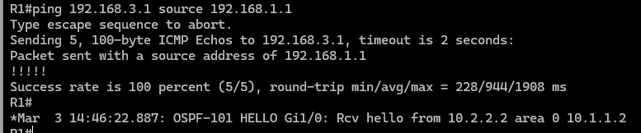
      - Re-issue the show crypto isakmp sa command.
R1# show crypto isakmp sa
IPv4 Crypto ISAKMP SA
dst src state conn-id status
10.2.2.1 10.1.1.1 QM_IDLE 1001 ACTIVE
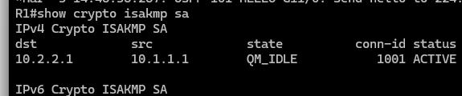
IPv6 Crypto ISAKMP SA

Questions:
Why was an SA created between R1 and R3 this time?
No, Routing protocol exchanges between routers are treated as non-interesting traffic. These packets bypass the IPsec process, meaning they are sent in the clear and are incapable of triggering an SA
What are the endpoints of the IPsec VPN tunnel?
10.1.1.1 (R1 G0/0/0), Dst: 10.2.2.1 (R3 G0/0/0)
      - Ping from PC-A to PC-C and then issue the show crypto ipsec sa command.

Question:
How many packets have been transformed between R1 and R3?
- A total of 29 packets have been processed by the IPsec SA. The counters for encapsulation and decapsulation both show 29, indicating symmetrical protected traffic flow between the peers
R1# show crypto ipsec sa

interface: GigabitEthernet0/0/0
Crypto map tag: CMAP, local addr 10.1.1.1

protected vrf: (none)
local ident (addr/mask/prot/port): (192.168.1.0/255.255.255.0/0/0)
remote ident (addr/mask/prot/port): (192.168.3.0/255.255.255.0/0/0)
current_peer 10.2.2.1 port 500
PERMIT, flags={origin_is_acl,}
#pkts encaps: 12, #pkts encrypt: 12, #pkts digest: 12
#pkts decaps: 8, #pkts decrypt: 8, #pkts verify: 8
#pkts compressed: 0, #pkts decompressed: 0
#pkts not compressed: 0, #pkts compr. failed: 0
#pkts not decompressed: 0, #pkts decompress failed: 0
#send errors 0, #recv errors 0

local crypto endpt.: 10.1.1.1, remote crypto endpt.: 10.2.2.1
plaintext mtu 1438, path mtu 1500, ip mtu 1500, ip mtu idb GigabitEthernet0/0/0
current outbound spi: 0x95B6C7B5(2511783861)
PFS (Y/N): Y, DH group: group24

inbound esp sas:
spi: 0x1EBD4016(515719190)
transform: esp-256-aes esp-sha-hmac ,
in use settings ={Tunnel, }
conn id: 2001, flow_id: ESG:1, sibling_flags FFFFFFFF80004048, crypto map: CMAP
sa timing: remaining key lifetime (k/sec): (4607999/671)
IV size: 16 bytes
replay detection support: Y
Status: ACTIVE(ACTIVE)

inbound ah sas:

inbound pcp sas:

outbound esp sas:
spi: 0x95B6C7B5(2511783861)
transform: esp-256-aes esp-sha-hmac ,
in use settings ={Tunnel, }
conn id: 2002, flow_id: ESG:2, sibling_flags FFFFFFFF80004048, crypto map: CMAP
sa timing: remaining key lifetime (k/sec): (4607999/671)
IV size: 16 bytes
replay detection support: Y
Status: ACTIVE(ACTIVE)

outbound ah sas:

outbound pcp sas:

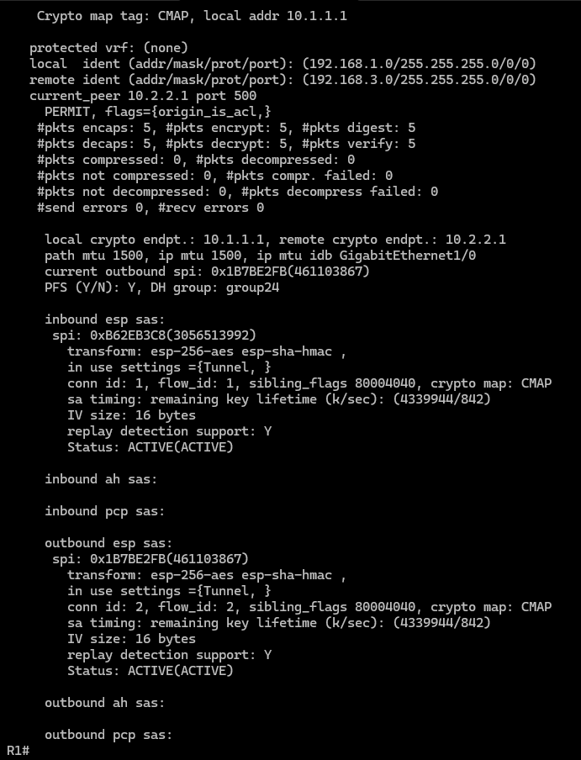
      - The previous example used pings to generate interesting traffic.

Question:
What other types of traffic would result in an SA forming and tunnel establishment?
- The IPsec security policy covers all traffic between the 192.168.1.0 and 192.168.3.0 networks. Regardless of the protocol (HTTP, FTP, etc.), any packet moving between these two internal LANs triggers the encryption process

Reflection
Would traffic on the Gigabit Ethernet link between PC-A and the R1 G0/0 interface be encrypted by the site-to-site IPsec VPN tunnel? Explain.
No, This site-to-site VPN secures only the WAN segment. Internal LAN traffic—such as packets moving from PC-A to R1—is not encapsulated, leaving it vulnerable to local interception before it reaches the encryption point

Router Interface Summary Table
Router Model | Ethernet Interface #1 | Ethernet Interface #2 | Serial Interface #1 | Serial Interface #2
1900 | Gigabit Ethernet 0/0 (G0/0) | Gigabit Ethernet 0/1 (G0/1) | Serial 0/0/0 (S0/0/0) | Serial 0/0/1 (S0/0/1)
2900 | Gigabit Ethernet 0/0 (G0/0) | Gigabit Ethernet 0/1 (G0/1) | Serial 0/0/0 (S0/0/0) | Serial 0/0/1 (S0/0/1)
4221 | Gigabit Ethernet 0/0/0 (G0/0/0) | Gigabit Ethernet 0/0/1 (G0/0/1) | Serial 0/1/0 (S0/1/0) | Serial 0/1/1 (S0/1/1)
4300 | Gigabit Ethernet 0/0/0 (G0/0/0) | Gigabit Ethernet 0/0/1 (G0/0/1) | Serial 0/1/0 (S0/1/0) | Serial 0/1/1 (S0/1/1)
Blank Line, No additional information
Note: To find out how the router is configured, look at the interfaces to identify the type of router and how many interfaces the router has. There is no way to effectively list all the combinations of configurations for each router class. This table includes identifiers for the possible combinations of Ethernet and Serial interfaces in the device. The table does not include any other type of interface, even though a specific router may contain one. An example of this might be an ISDN BRI interface. The string in parenthesis is the legal abbreviation that can be used in Cisco IOS commands to represent the interface.
Note: ISR G2 devices have Gigabit Ethernet interfaces instead of Fast Ethernet Interfaces.
--------------------
Router R1 after Part 1
end of document

